Chapter 2 #1

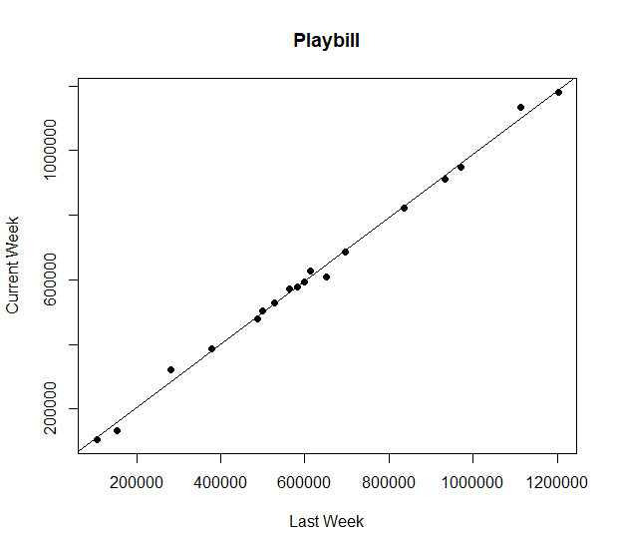

\* Looks like Current Week is pretty close to the value for Last Week for most of the data points

Chapter 2 #2

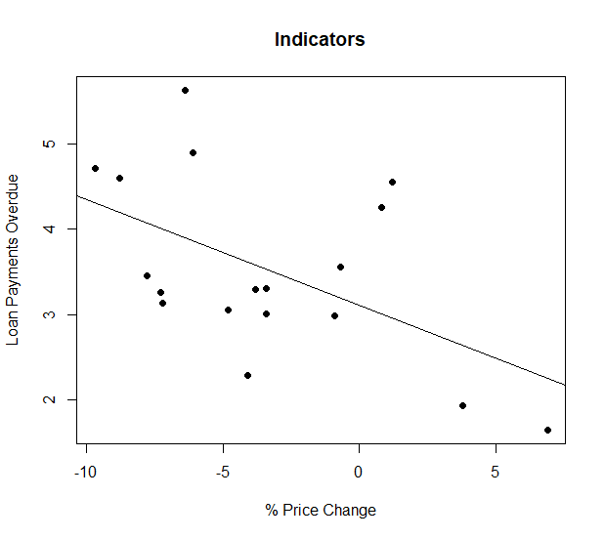

Chapter 2 #3

